Corbett Art Center
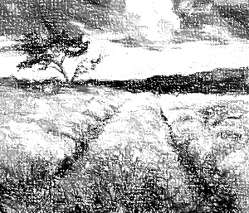
The Art Center gallery, located in the historic Corbett mansion, is open to the general public. The gallery features local artists and the work of students taking classes at the center.
The hours of operation are:
Day Hours
Monday – Wednesday…. Noon to 5 p.m.
Thursday – Friday …………. Noon to 8 p.m.
Saturday …………………. 11 a.m. to 5 p.m.
Sunday ………………………………. Closed
The Art Center offers art classes throughout the year. Each class has a beginning, intermediate, and advanced section. Each section lasts two months. For more information email chorikoshi@aspenfall.org. Art classes include the following:
Class | Starting Months | Description
Art History | January and July | Survey of medieval to modern art
Drawing | February and August | Freehand drawing, light and shadow, composition, and perspective, and portrait
Painting | April and October | Acrylics, oils, and watercolors
Photography | June and December | Point and shoot, DSLRs, Photoshop, portraits, landscapes, and sports
Sculpture | May and November | Medium, modeling, busts, and abstraction
Watercolors | March and September | Washes, wet-in-wet, and dry brush

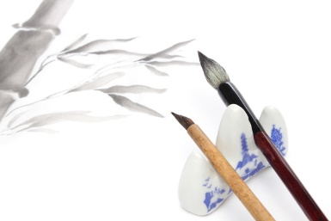
Class fees are as follows:
Class Fees
Groups | Ages | Cost
Students | 12 to 17 | $ 64.00
Young Adults | 18 t0 24 | 78.00
Adults | 25 to 59 | 125.00
Seniors | 60+ | 38.00

